Add Subscriber Account

Version Control:

Use Case Name: |  | Add Subscriber Account
Use Case Owner: |  | Sumit Borade
Current Version |  | 0.1
Use Case Version History
Modified Date | Version |  | Modified By | Change Description
July 9, 2009 | 0.1 |  | Tom Schnarr | Initial Version

Brief Description:
This use case describes the process by a YouSee subscriber is identified to SMP. This use case will be subsequently call the details of other use cases to activate those services.

Related Documents
- YouSee SMP SOW2Architecture Requirements Document
- YouSee SMP SOW2 Business Requirements Document

Related Use Cases
- Activate Broadband over Cable
- Activate Voice and Broadband over Cable
- Activate new video subscriber with optional VoD
- Activate new mobile broadband subscriber

Pre-Conditions
- Subscriber resides in a residence served by YouSee cable footprint
- Subscriber is an acceptable credit risk.

Post-Conditions
- Subscriber is free to use the services they have ordered.

Use Case

Primary Flow Diagram
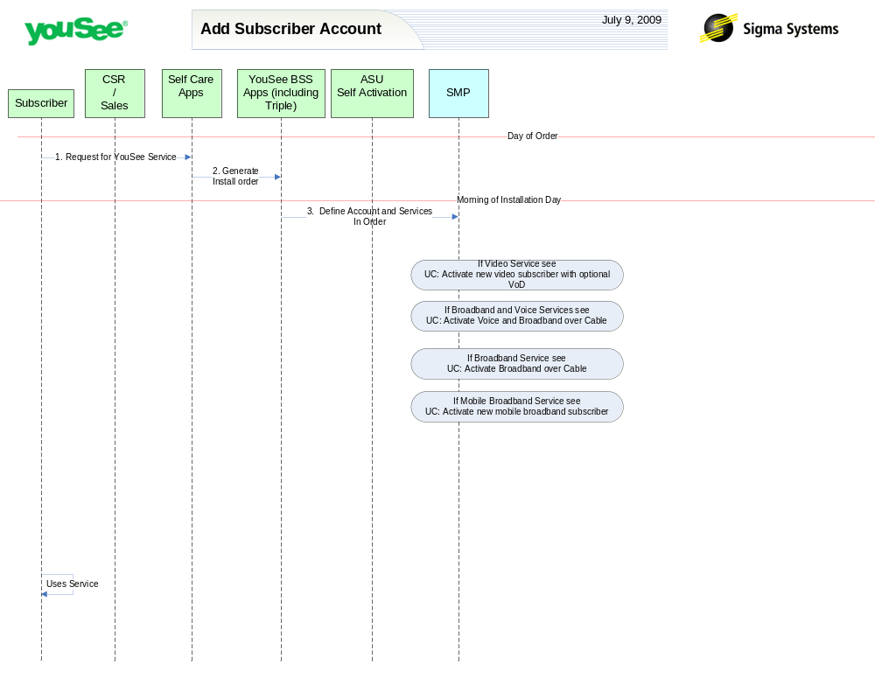

Primary Flow Detail
# | Actor: Key Action | Description | Alternate Flows/Details
Note: The first set of steps in this use case occurs on the day of order. This means the day the subscriber makes contact with YouSee to order services.
 | Subscriber: Contacts YouSee via Self Care portal and orders Services | Subscriber does not currently have service from YouSee but he is served by YouSee cable plant. | Alternatively the subscriber could order the service by contacting the CSR who would enter the order into the BSS applications directly.
 | Self Care: Order is created in YouSee BSS applications | From the Self Care Portal, the order is created for fulfillment in the YouSee BSS Applications  The BSS components perform a variety of qualification and product catalog decomposition and communicate an order to SMP defining the subscriber, address, candidate CPE and services as ordered by the customer.
Note: The next step occurs at the time that the installation order goes active, namely the morning that the activation is due to occur. This may occur immediately in the event of a same day installation.
 | YouSee BSS: Order is communicated to SMP | YouSee BSS (Triple) will communicate the order to SMP through SMP’s Order Management API. Triple will provide logical services and service attributes. SMP will be required to translate these service/service attributes to engineering level resources and resource attributes. | If the subscriber ordered a ‘leased’ CM, YouSee arranged to ship the device to the customer.  If the subscriber ordered a ‘professional installation’ YouSee schedules a technician for the installation.
Note: Depending upon the set of services ordered, secondary Use cases are implemented for those specific services. See the following Use Cases:
- Activate new video subscriber with optional VoD
- Activate Broadband over Cable
- Activate Voice and Broadband over Cable
- Activate new mobile broadband subscriber

